Task 3: Dashboard Design

Objective: Design an interactive dashboard for business stakeholders.

Tools: Power BI

Deliverables: Interactive Dashboard + PPT summary

a.Choose right KPIs (Sales, Profit, Growth)

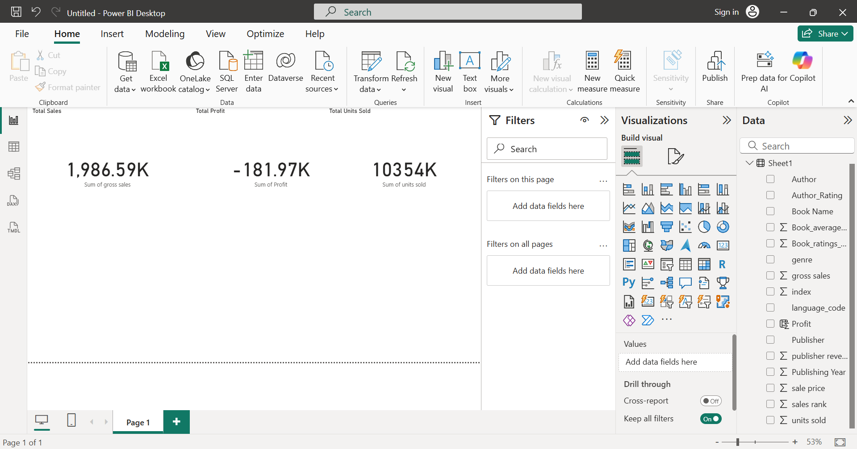

‘

b.Use slicers/filters for interactivity

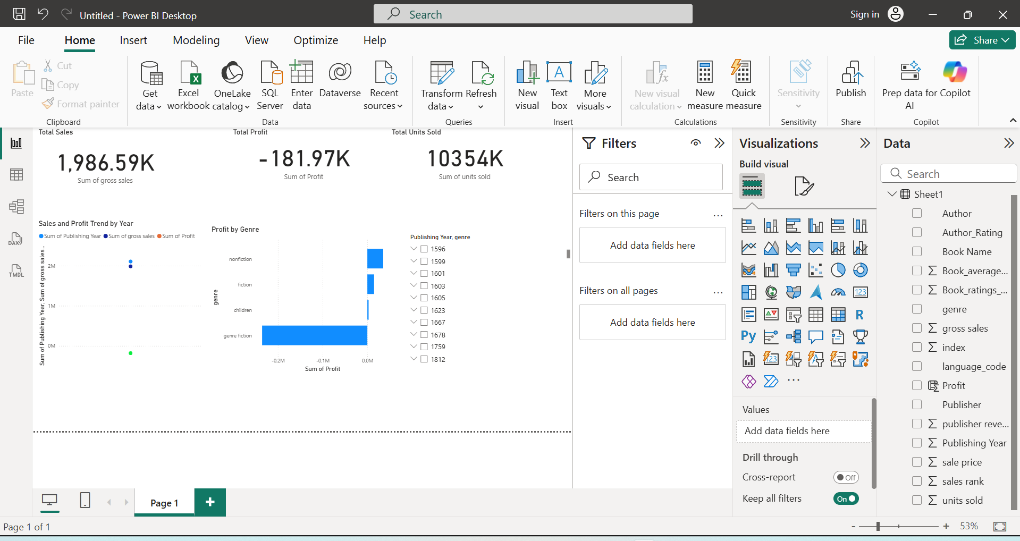

c.Include time-series analysis

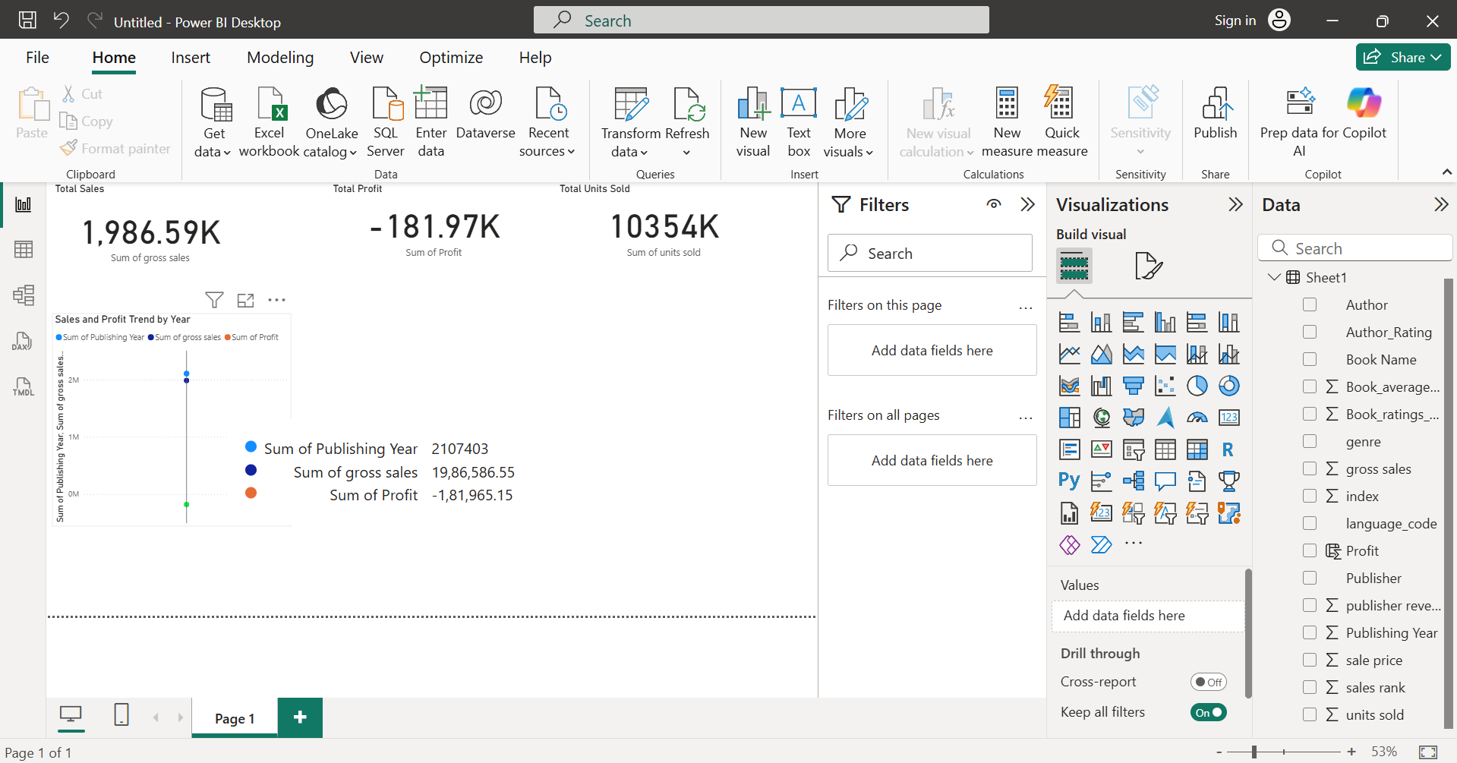

d.Add cards for totals/summary

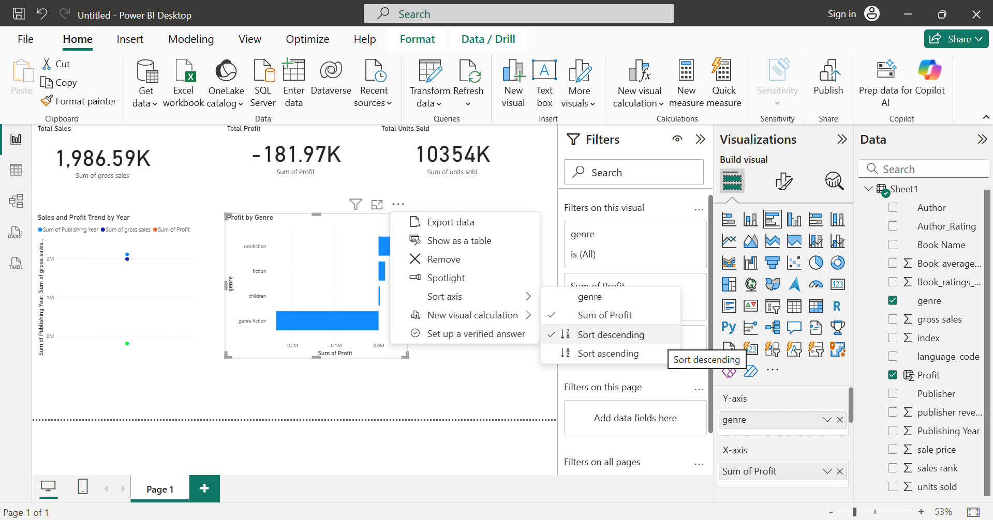

e.Apply consistent color theme

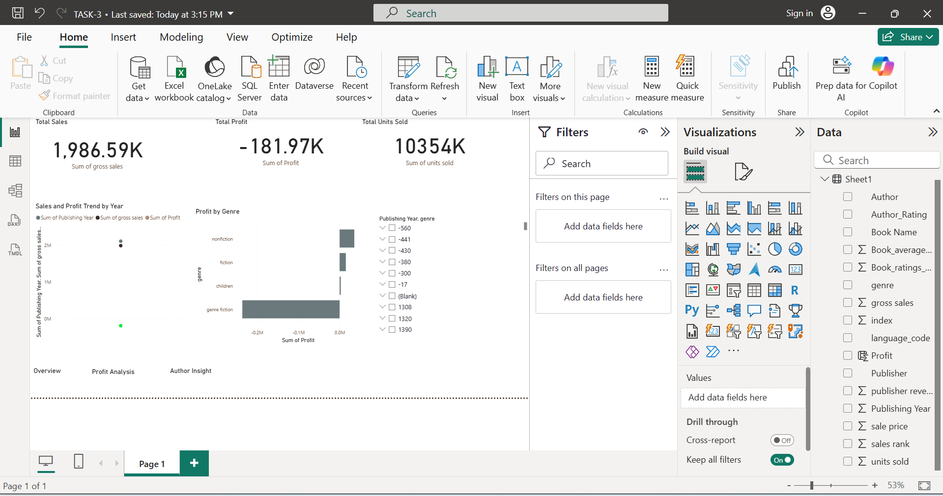

f.Create navigation menu (if possible)

